Maze Game Proposal

Team information:

Team Name : Gameboy.CN

Team member:

Jiachen Ma,

Kuntao Zhu,

Weihua Liu.

Project Name:

Maze game Ver. 1.0.

Initial idea

A general maze game, using gravity accelerometer, gyroscope. Different difficulty will correspond to different stage.

Customer segment:

Preschool children and players under 12.

Value proposition:

The mobile app will develop player’s intelligence, patience, ambitions, and ability of time management.

User research:

Action:

Environment:

Interaction:

O:

User: 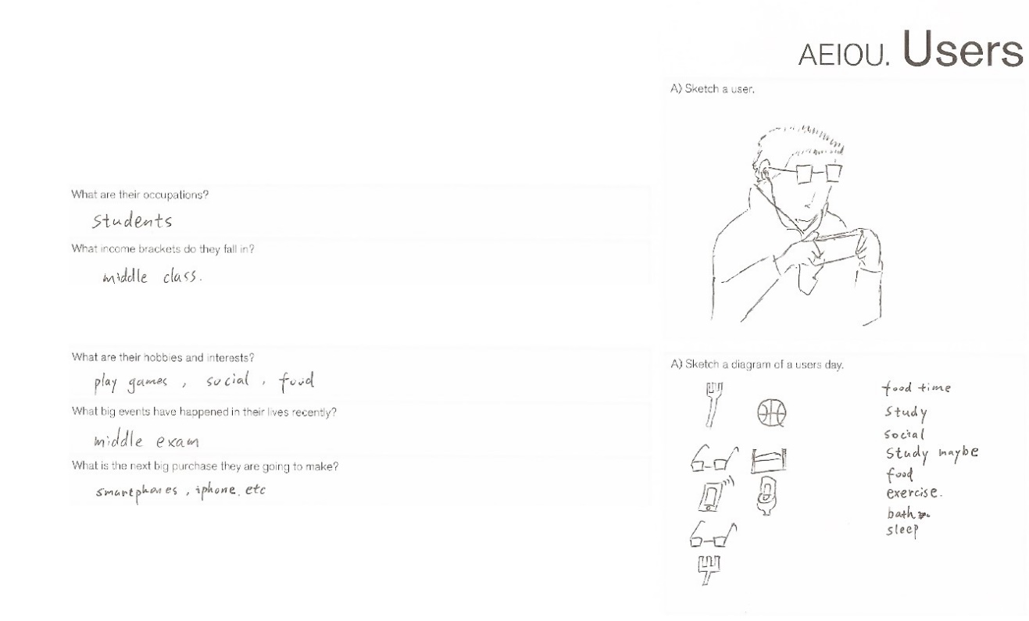

Related apps :

Naught, Maze Master, all general maze games are related to our maze game.

Unique attractive point:

Difficulty assign. We make different difficulty to the user in a mild way which user will not feel frustrated after first few rounds. But user will feel how challenging this game could be.

Gravity accelerometer. Instead of using key board the control the game, we use gravity to conduct the game progress.

Empathy Map:

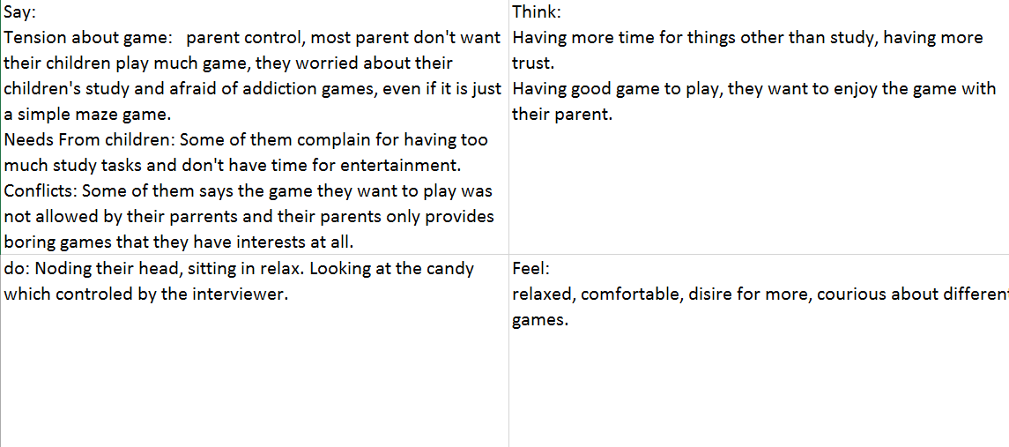

Needs: Children want more game time, or other kinds of entertainments, less school work.

Insights: Most parents hold a negative attitude toward game, even if it’s just a simple maze game.

Contradictions: The game provided by parents are too complex thus they’re not suitable for children. The game that children like are not acceptable by parents.

Tensions: Time consuming, distracting.

Surprises: Lot of parents worry about the in-app purchase.

|  |  |
| --- | --- |
|  | Title: |
| Preschool student |
| Description of life: |
| Study, sport, game |
| Goal: | Experience: |
| Good grade, enough game. | Cell phone, laptop |
| Problem: |  |
| Too much homework, too few free time. | Activity/ interests: |
|  | Basketball, pizza, puzzle game. |

Point of view:

1.User preschool children

2. We were surprised to discover that children do not have enough time/ access to games they like.

3. Insight: It would consume children less time to play game and amuse them in a more efficient way so that they will have more patience in study, develop their intelligence better.